Faculty of Engineering
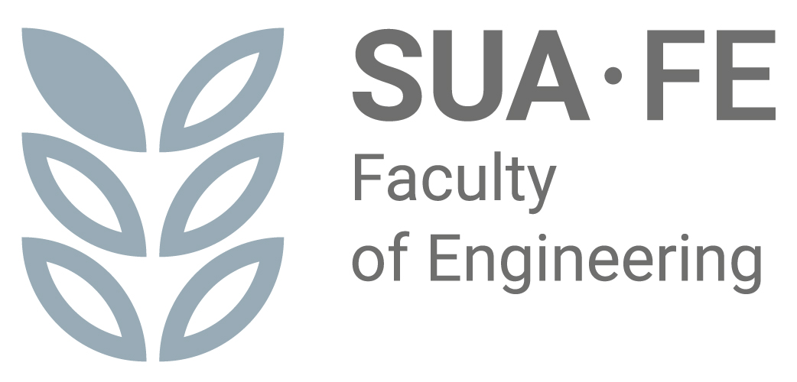
SLOVAK UNIVERSITY OF AGRICULTURE IN NITRA

Adress: | Tr. A. Hlinku 2, 949 76 Nitra
Phone: | 037/641 5489
E-mail: | dtf@uniag.sk
Web page: | https://tf.uniag.sk/sk/uvodna-stranka
 | http://studujtechniku.sk/
Terms and Conditions of the Admission Process for First-Cycle Higher Education (Bachelor's Degree) in the "Technology Operations Management" Study Program at the Faculty of Engineering, Slovak University of Agriculture in Nitra, for the Academic Year 2026/2027

BASIC ADMISSION REQUIREMENTS
The fundamental requirement for admission to Bachelor's degree studies is the attainment of full secondary education or full secondary vocational education (completion of secondary school with a school-leaving examination/Matura).

ADDITIONAL ADMISSION CONDITIONS
- Applicants will be ranked based on the evaluation criteria specified in the annex. For the "Technology Operations Management" program, candidates may be admitted if they achieve at least the minimum required aggregate score from their school-leaving examination (Matura) and the grade point average in specific subjects (Mathematics, Physics) obtained during individual years of secondary school.
- Upon request, applicants with specific needs will have the form and method of their entrance examination determined based on an assessment of their requirements, taking their specific needs into account.

GENERAL INFORMATION ON THE ADMISSION PROCESS
- A single application allows an applicant to apply for two study programs within a single admission procedure fee.
- The Faculty of Engineering may admit applicants without an entrance examination or a personal interview, based on the results achieved in the school-leaving examination (Matura).
- Applicants shall attach a Curriculum Vitae (CV), a copy of their School-Leaving Certificate, and proof of payment of the admission administration fee to their electronic application.
- A certified copy of the School-Leaving Certificate must be sent to the Study Department of the Faculty of Engineering at the following address:

Andrea Homolová

Study department Faculty of Engineering SUA in Nitra
Tr. A. Hlinku 2 949 76 Nitra

- Following the admission procedure, applicants will receive a decision on the admission results within 30 days of the verification of their eligibility for admission. An applicant who has not yet met the educational requirement (Matura) at the time of the admission committee's session may be provisionally admitted.
- An applicant admitted to a study program is required to inform the Faculty of Engineering whether they intend to enroll, following the written instructions received alongside the admission decision (an electronic return-slip is part of the decision).
- The applicant's personal data (name, surname, personal identification number, address, etc.) will be processed in accordance with the Personal Data Protection Act No. 18/2018 Coll. solely for the purposes of the admission process and shall not be disclosed for other purposes.
- The Dean may accept the results of admission procedures from other faculties of the Slovak University of Agriculture in Nitra or other higher education institutions.
- The Dean may offer applicants who did not rank high enough for their chosen study program the option of admission to an alternative program with a lower number of applicants.
- The Faculty of Engineering reserves the right not to open a study program if the number of applicants is insufficient. In such a case, the Faculty of Engineering will offer the applicant another accredited study program. If the applicant is not interested in the alternative program, the application, including all attachments and the admission fee, will be refunded to the applicant.

INFORMATION FOR INTERNATIONAL APPLICANTS
International applicants shall generate a recognition statement via the following link: https://uznavanie.minedu.sk/recognition-statement/ in the section "Statement on the Recognition of the Level of Education".
International applicants (with the exception of applicants from the Czech Republic and applicants who passed the school-leaving examination in the Slovak language) applying for a study program provided by the SUA in Nitra in the Slovak language are required to complete an online test and an online oral interview to determine their level of proficiency in the Slovak language. The testing is administered by the Language Centre of the SUA in Nitra (https://cj.uniag.sk/sk/domov/) in two sessions, about which applicants will be informed in advance.
Following the language examination, the applicant will be issued a certificate of the aggregate result of the online test and online interview, corresponding to the language levels of the Common European Framework of Reference for Languages (CEFR). The test and the certificate are subject to a fee of €30. If the applicant's language proficiency level is lower than A1, the applicant will not be admitted to the study program. If the applicant's language proficiency level is A1, the applicant has met one of the admission conditions; however, they are obligated to complete a 30-hour paid Slovak language course organized by the Language Centre of the SUA in Nitra (course fee: €120). The course will take place from August 24, 2026, to September 4, 2026. Upon completion of the course, the applicant will be issued a certificate of completion. If the applicant's language proficiency level is A2 or higher, the applicant has met one of the conditions for admission.
Detailed information regarding the test and the course will be available on the Language Centre website (https://cj.uniag.sk/sk/domov/).

ESTIMATED NUMBER OF ADMITTED STUDENTS
BACHELOR'S STUDIES | Study Mode | Duration of Study | Planned Number of Students
Technology Operations Management | Full-time / Full-time (combined method) | 3 years | 40/20

APPLICATION SUBMISSION AND FEES
Applications must be submitted electronically only.
- E-application deadline (1st Round): by April 30, 2026
- E-application deadline (2nd Round): by July 15, 2026
- Admission Procedure Fee: €45

Payment details for Internet Banking / Bank Transfer:
- IBAN: SK40 8180 0000 0070 0006 6247
- Constant Symbol (KS): 0558
- Variable Symbol (VS): 103900
- Specific Symbol (ŠS): 103900721
- Message for Recipient: Surname and First Name of the applicant (please write without diacritics/accents)

Beneficiary Information:
- Name and Address: Slovak University of Agriculture in Nitra, Trieda A. Hlinku 2, 949 76 Nitra, Slovakia
- Beneficiary Bank: State Treasury (Štátna pokladnica), Radlinského 32, 810 05 Bratislava

International Payment Details:
- IBAN: SK40 8180 0000 0070 0006 6247
- BIC/SWIFT: SPSRSKBA
- Constant Symbol (KS): 0558
- Variable Symbol (VS): 103900
- Specific Symbol (ŠS): 103900721
- Message for Recipient: Surname and First Name of the applicant (without diacritics)

CONTACT INFORMATION
Study Department (Bachelor’s / Level I):
- Andrea Homolová – andrea.homolova@uniag.sk
Vice-Dean for Education:
- doc. Ing. Ján Kosiba, PhD. – jan.kosiba@uniag.sk
Vice-Dean for International Students:
- Ing. Katarína Kollárová, PhD. – katarina.kollarova@uniag.sk
Coordinator for Applicants with Specific Needs:
- prof. Ing. Maroš Korenko, PhD. – maros.korenko@uniag.sk

OFFICIAL NOTICE
Published on the Faculty of Engineering website: https://tf.uniag.sk/en/admission-requirements and on the Higher Education Portal: www.portalvs.sk

The Program Committee of the " Technology Operations Management " study program approved the proposal for the terms and rules of the admission process, including provisions for students with specific needs, on November 13, 2025.

Annex: Evaluation Criteria for Applicants for First-Cycle Higher Education (Bachelor's Degree)
a) The evaluation of the school-leaving examination (Matura) results for a single subject is specified in the table below:
Evaluation |  | Number of points
percentile (%) | degree (z) | external (%) | internal (z)
90 - 100 | 1 | 12 | 10
80 - 89 | 2 | 10 | 8
70 - 79 | 3 | 8 | 6
60 - 69 | 4 | 6 | 4

For applicants who completed their school-leaving examinations (Matura) under previous regulations, the following grading scale shall apply:
averages | number of points
1.00 – 1.50 | 30
1.51 – 2.00 | 25
2.01 – 2.50 | 20
2.51 – 3.00 | 15
over 3.01 | 10

b) Point evaluation based on the grade point average (GPA) in two subjects (Mathematics, Physics) obtained during individual years of secondary school:
averages | number of points
1.00 – 1.25 | 80
1.26 – 1.50 | 75
1.51 – 1.75 | 70
1.76 – 2.00 | 65
2.01 – 2.25 | 60
2.26 – 2.50 | 55
2.51 – 2.75 | 50
2.76 – 3.00 | 45
over 3.01 | 40

