FACULTY OF ECONOMICS AND MANAGEMENT
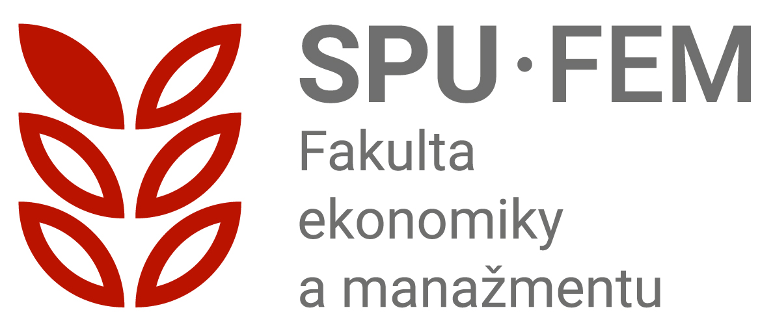
SLOVAK UNIVERSITY OF AGRICULTURE IN NITRA
Address: | Tr. A. Hlinku 2, 949 76 Nitra
Phone: | 037/641 5125, 037/641 5177
E-mail: | prijimacie.konanie_fem@uniag.sk
Web: | www.fem.uniag.sk
 | https://www.podnazelenu.sk/fakulty-fem/

Terms and conditions of the admission procedure for the 2nd level of university study in the study program Economics and Business Administration, Faculty of Economics and Management, Slovak University of Agriculture in Nitra, for the academic year 2026/2027

BASIC CONDITIONS FOR ADMISSION TO STUDY
- The basic condition for admission (§ 56 of the Act on Higher Education Institutions) to a second-level study program is the completion of a first-level study program in the same or a related field of study.
- An applicant who does not demonstrate fulfilment of the basic admission requirement at the time of verification of compliance with the admission conditions may be admitted to study conditionally, provided that they are obliged to demonstrate fulfilment of the basic admission requirements for study no later than on the date designated for enrolment.
- The decisive criteria for the selection of students for second-level studies shall be the academic performance achieved in first-level studies and the results of the bachelor’s state examination.
- The maximum number of points that a student may achieve is 80 points (the grade point average from first-level studies plus the total number of points obtained for grades in the bachelor’s examination subjects). The individual point allocations are specified in Annex 1, and the condition for admission to second-level studies is the attainment of at least 10 points.
- International applicants for master studies shall be admitted on the basis of an assessment of their overall grade point average and an evaluation of the submitted documentation regarding language proficiency.

ADITIONAL CONDITIONS FOR ADMISSION TO STUDY
The stated evaluation criteria for assessing applicants’ eligibility for admission are supplemented, in accordance with Section 57(1) of Act No. 131/2002 Coll. on Higher Education Institutions, by the following aspects:
  - Social view (orphans, half-orphans),
  - Applicants with physical disabilities,
  - Foreign Slovaks.
For an applicant with special needs, upon their request and based on the assessment of their specific needs, the form of the entrance examination and the manner of its administration shall be determined.

GENERAL INFORMATION ON ADMISSION PROCEDURE
- Applicants for study submit an electronic application via the SUA University Information System or through the Higher Education Portal,
- within one application, it is possible to apply for two study programs under a single admission fee,
- the application must include: the level and form of study, the name of the higher education institution, the name of the faculty, and the study program,
- applicants for study must submit with their electronic application in the UIS: a CV, proof of payment of the fee for the material provision of the entrance procedure, documentation of language proficiency, a copy of the diploma and the state examination certificate, and the supplement to the diploma from the first-level studies (except for applicants who completed the bachelor’s degree at FEM SUA in Nitra),
- a verified copy of the diploma, the state examination certificate, and the supplement to the diploma from first-cycle studies (except for applicants who completed their bachelor’s degree at FEM SPU in Nitra) shall be sent to the Study Department of FEM SPU in Nitra at the following address:

Study Department FEM SUA Nitra
Tr. A. Hlinku 2
949 76 Nitra

  - applicants for second-level study programs shall be placed on the ranking list based on the points obtained according to the admission criteria, with the condition for admission to second-level studies being the attainment of at least 10 points.
- after the entrance procedure, the applicant shall receive a decision on the outcome of the admission process within 30 days of verification of fulfilment of the admission conditions. An applicant who has not met a condition (e.g., the school-leaving examination) at the time of the admission committee meeting may be conditionally admitted.
- an applicant who is admitted to a study program is obliged to inform the faculty whether they will enroll in the study program, following the instructions provided in writing together with the admission decision (the e-return form is part of the decision).
- personal data of the applicant (name, surname, personal identification number, address, etc.) shall be used in accordance with Act No. 18/2018 Coll. on Personal Data Protection solely for the purposes of the admission procedure and shall not be disclosed for other purposes.
- the dean may offer applicants who were not placed on the ranking list for their applied study program the opportunity to be admitted to an alternative program with a lower number of applicants.
- the faculty reserves the right not to open a study program with a low number of applicants. In such a case, the faculty shall offer the applicant another accredited study program. If the applicant does not wish to enroll in the alternative study program, the application with all attachments, as well as the admission fee, shall be returned to the applicant.

INFORMATION FOR INTERNATIONAL APPLICANTS
International applicants shall create the endorsement via the following link:
https://uznavanie.minedu.sk/recognition-statement/ in the section “Endorsement for Recognition of the Level of Education”.
International applicants (with the exception of applicants from the Czech Republic and those who completed the secondary school leaving examination in Slovak language) who apply for a study program offered at SUA Nitra in Slovak language are required to take an online test and an online oral interview designed to assess their proficiency in the Slovak language. The testing is administered by the Language Centre of SUA Nitra (https://cj.uniag.sk/sk/domov/) in two dates about which applicants will be informed in advance.
After completing the language examination, the applicant will be issued a certificate summarizing the results of the online test and online interview, which will correspond to the language level according to the Common European Framework of Reference for Languages (CEFR). The test and certificate are subject to a fee of €30. If the applicant’s language proficiency level is below A1, they will not be admitted to the study program.
If the applicant’s language proficiency level is A1, they have met one of the conditions for admission but are required to complete a 30-hour paid Slovak language course organized by the Language Centre of SUA Nitra (course fee: €120). The course will take place from August 24, 2026, until September 4, 2026. Upon completion of the course, the applicant will receive a certificate of completion.
If the applicant’s language proficiency level is A2 or higher, they have met one of the conditions for admission. Detailed information about the test and the course will be available on the website of the Language Centre (https://cj.uniag.sk/sk/domov/).
International applicants for master studies who apply for a study program offered at FEM SUA in Nitra in English language shall be admitted based on proof of English language proficiency. The following certificates are accepted for admission: IELTS, TOEFL, and Cambridge.
- IELTS: accepted score from 6.0 and higher in each section (Listening, Reading, Writing, Speaking),
- TOEFL: accepted score of iBT (online): 80-90 points and PBT (paper-based test): 550-575 points,
- Cambridge: accepted minimum level of B2 or C1/C2.

EXPECTD NUMBER OF STUDENTS
MASTER STUDIES | Form of study | Duration of study | Expected number of students | Tuition fee/acad.year (in external form of study)
Economics and Business Administration | Full-time /  Full-time combined /  External | 2 years | 150  30  20 | 1400,- €
Economics and Business Administration* | Full-time | 2 years | 40

* study program accredited in English language

Applications are submitted exclusively online.
Deadline for submitting the electronic application (e-application): July 7, 2026
Admission Fee: 40 €

Payment method for the electronic application:
- Recipient name and address: Slovenská poľnohospodárska univerzita, Tr. A. Hlinku 2, 949
76 Nitra
- IBAN: SK 408180000000 7000066247
- Bank name and address: Štátna pokladnica, Radlinského 32, 810 05 Bratislava
- Constant symbol (KS): 0558
- Variable symbol (VS): generated by the system
- specific symbol (ŠS): 106900721
- Message for the recipient – surname and name of the applicant (to be entered without diacritics).

For making a payment from other EU countries, the following additional information is required:
- BIC/SWIFT code: SPSRSKBA
- Message for the recipient – specific symbol + surname and name of the applicant (to be entered without diacritics)

Study department II. Level of study FEM SUA in Nitra, door number 108, 1st floor, S pavilion, FEM:
Dagmar JORDANOVOVÁ
phone.: +421 / 37 641 5177
e-mail.: Dagmar.Jordanovova@uniag.sk
Erika KLINKOVÁ
phone.: +421 / 37 / 641 5897
e-mail.: Erika.Klinkova@uniag.sk

Vice -dean for Education and Accreditation of Study Programs:
Ing. Iveta Košovská, PhD.

Vice-dean for Internationalization:
Ing. Veronika Hrdá, PhD.

Coordinator for Applicant with Special Needs:
PhDr. Anna Mravcová, PhD.

Published on the web page of the Faculty of Economics and Management: https://www.fem.uniag.sk/sk/bakalarske-studium and on a Higher Education Portal www.portalvs.sk
Prepared by: Ing. Iveta Košovská, PhD.
The Program Committee of the study program Economics and Business Administration approved the proposal of the conditions and rules of the admissions procedure for this study program, taking into account the specific requirements of students with special needs, on January 31, 2026.
The terms and conditions of the admissions procedure for the study program Economics and Business Administration were approved by the Council for the Internal Quality Assurance System of Education at SUA Nitra, on February, 26 2026.

Appendix Evaluation Criteria for Applicants to Second-Level Studies

- Point evaluation of grade point average (maximum 40 points)
Points | Study average
40 | 1,00
39 | 1,04
38 | 1,08
37 | 1,11
36 | 1,15
35 | 1,19
34 | 1,23
33 | 1,26
32 | 1,30
31 | 1,34
30 | 1,38
29 | 1,42
28 | 1,45
27 | 1,49
26 | 1,53
25 | 1,57
24 | 1,60
23 | 1,64
22 | 1,68
21 | 1,72
20 | 1,76
19 | 1,79
18 | 1,83
17 | 1,87
16 | 1,91
15 | 1,94
14 | 1,98
13 | 2,02
12 | 2,06
11 | 2,09
10 | 2,13
9 | 2,17
8 | 2,21
7 | 2,25
6 | 2,28
5 | 2,32
4 | 2,36
3 | 2,40
2 | 2,43
1 | 2,47
0 | 2,51

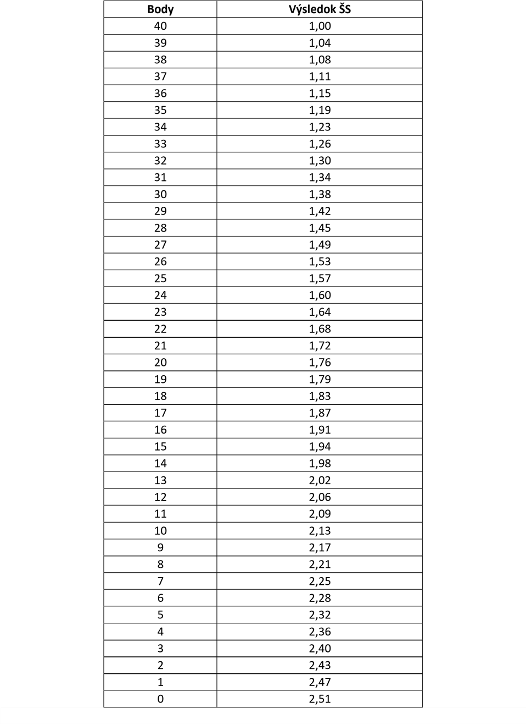
- point evaluation of state exam (maximum 40 points)
By summarizing the two point- values indicated (a + b), the final point score is obtained, based on which the ranking of applicants for second-level studies within each study program will be determined.

