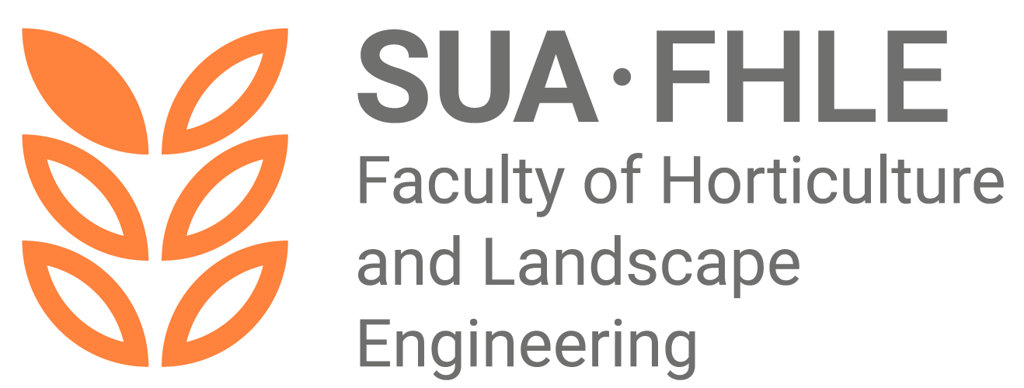
FACULTY OF HORTICULTURE AND LANDSCAPE ENGINEERING
SLOVAK UNIVERSITY OF AGRICULTURE IN NITRA

Adress: | Tr. A. Hlinku 2, 949 76 Nitra
Phone: | 037/641 5412, 037/641 5441
E-mail: | dekfzki@uniag.sk
Web page: | www.fzki.uniag.sk  www.podnazelenu.sk/fakulty-fzki/

Terms and Rules of the Admission Procedure for the Second Level of Higher Education in the study programme International Master of Horticulture Science – taught in English, Faculty of Horticulture and Landscape Engineering, Slovak University of Agriculture in Nitra,
for the academic year 2026/2027

Study programme taught in English. More information: https://www.fzki.uniag.sk/sk/inzinierske-studijne-programy-v-anglickom-jazyku

BASIC ADMISSION REQUIREMENTS
The basic requirement for admission to the Master’s (second-cycle) study programme is the completion of a first-cycle (Bachelor’s) study programme in the same or a related field of study, successfully completed by a state (final) examination. An applicant who does not prove fulfilment of the basic admission requirement at the time of verification of admission requirements may be admitted conditionally. In such a case, the applicant is obliged to prove fulfilment of the basic admission requirements no later than on the date specified for enrolment in the study programme.

STUDY ADDITIONAL ADMISSION REQUIREMENTS
The ranking of applicants will be based on the results achieved in previous first-cycle studies, including the state (final) examination. The evaluation criterion will be the weighted grade average of completed courses over the entire previous first-cycle study and according to additional requirements of the specific study programme. The minimum number of points required for admission is 5 points, as follows: the applicant obtains 5 points if the overall weighted grade average of completed courses over the entire first-cycle study is less than or equal to 2.5, and the applicant obtains 5 points if the result of the state (final) examination is less than or equal to 2.5. If the applicant completed a first-cycle study programme in a related field at another faculty or higher education institution, they are required to submit the results of their Bachelor’s studies as stated above, namely the overall weighted grade average of completed courses over the entire first-cycle study and the result of the state (final) examination. After admission to the Master’s study programme, the study plan will be specified in order to complete courses within the study plan to the extent determined by the Dean.
Applicants will undergo an admission interview conducted in English, which will take place on a date announced in advance. The applicant will be informed of the interview date after the application has been registered, after 15 July 2026. The interview will not be knowledge-based; its purpose is to demonstrate the applicant’s aptitude for studying the selected study programme.

GENERAL INFORMATION ON THE ADMISSION PROCEDURE
- An applicant for study may apply for multiple study programmes offered by the Faculty of Horticulture and Landscape Engineering within one application (under a single admission fee).
- An applicant who completed their bachelor’s degree outside the Slovak University of Agriculture in Nitra must include in the application a scan of the proof of completion of studies together with the diploma supplement, which applicants upload electronically via the University Information System (UIS).
- A certified copy of the proof of completion of studies (notary, registry office) together with the diploma supplement must be submitted by applicants at enrolment; otherwise, they will not be enrolled in the study programme.
- Incomplete applications (e.g. without proof of payment of the fee) will not be accepted.
- After the admission procedure, the applicant will receive a decision on the result of the admission procedure within 30 days from the verification of fulfilment of the admission requirements. An applicant who does not meet the conditions at the time of the meeting of the admissions committee may be conditionally admitted.
- An applicant who is admitted to one of the study programmes is obliged to inform the faculty whether they will enrol in the study programme according to the instructions received in written form together with the admission decision (the e-return form is part of the decision).
- The applicant’s personal data (name, surname, personal identification number, address, etc.) will be used in accordance with Act No. 18/2018 Coll. on Personal Data Protection solely for the purposes of the admission procedure and may not be provided for other purposes.
- The Dean may accept the results of the admission procedure from other faculties of the Slovak University of Agriculture in Nitra or from other higher education institutions.
- The Dean may offer applicants who were not ranked for the study programme they applied for the possibility of admission to an alternative programme with a lower number of applicants.
- The faculty reserves the right not to open a study programme for which a low number of applicants apply. In such a case, the faculty will offer the applicant another accredited study programme.

INFORMATION FOR FOREIGN APPLICANTS OR APPLICANTS WHO COMPLETED THE FIRST LEVEL OF STUDY ABROAD

an applicant may apply for several study programmes delivered by the Faculty of Horticulture and Landscape Engineering in one application (within one admission fee),

an applicant who completed Bachelor’s studies outside the Slovak University of Agriculture in Nitra is required to upload a scan of the certificate of completion of studies together with the Diploma Supplement electronically via the University Information System (UIS),

a certified copy of the certificate of completion of studies (certified by a notary public or registry office) together with the Diploma Supplement must be submitted by the applicant at enrolment; otherwise, the applicant will not be enrolled in the study programme,

incomplete applications (e.g. without proof of payment of the admission fee) will not be accepted,

after the admission procedure, the applicant will receive a decision on the result of the admission procedure within 30 days from the verification of fulfilment of admission requirements. An applicant who does not meet the requirements at the time of the meeting of the admission committee may be admitted conditionally,

an applicant who is admitted to a study programme is obliged to inform the faculty whether they will enrol in the study programme according to the instructions received in written form together with the admission decision (the e-return slip is part of the decision),

the applicant’s personal data (name, surname, personal identification number, address, etc.) will be processed in accordance with Act No. 18/2018 Coll. on the Protection of Personal Data solely for the purposes of the admission procedure and must not be provided for other purposes,

the Dean may accept the results of admission procedures carried out at other faculties of the Slovak University of Agriculture in Nitra or at other higher education institutions,

the Dean may offer applicants who were not placed on the ranking list for the applied study programme the possibility of admission to an alternative study programme with a lower number of applicants,

the faculty reserves the right not to open a study programme with a low number of applicants. In such a case, the faculty will offer the applicant another accredited study programme.

INFORMATION FOR INTERNATIONAL APPLICANTS OR APPLICANTS WHO COMPLETED THE FIRST CYCLE OF STUDY ABROAD
International applicants are required to obtain a recognition statement via the following link:
https://uznavanie.minedu.sk/recognition-statement/

EXPECTED NUMBER OF STUDENTS
Second-cycle (Master’s) study programme in the field of Agriculture and Landscape Management
MASTER’S (ENGINEER’S) STUDY PROGRAMME | Length of study | Form of study | Planned number of students | Tuition fee / academic year
International Master of Horticulture Science | 2 years | full-time – English language | 5 | 2200,00 €

Submission of applications is carried out exclusively electronically.
Application deadline (e-application): by 15 July 2026
Admission procedure fee: €60.00
Method of payment for the electronic application and the admission procedure: cashless payment according to the instructions provided in the electronic application. To complete the payment of the admission procedure fee, please follow the instructions in the electronic application.
For payments from other EU countries, the following details are also required:
o BIC/SWIFT code: SPSRSKBA
o message for the recipient – specific symbol + surname and name of the applicant (to be entered without diacritics)
In case of questions, please contact the Study Department of the Faculty of Horticulture and Landscape Engineering, Slovak University of Agriculture in Nitra, Tulipánova 7, 949 76 Nitra:
Study Department: Ing. Ivana Mesjarová
Tel.: +421 37 641 5412; e-mail: ivana.mesjarova@uniag.sk
Study Department – second cycle of study: Ing. Mária Šufliarska
Tel.: +421 37 641 5412; e-mail: maria.sufliarska@uniag.sk
Vice-Dean for Educational Activities: doc. Ing. arch. Roberta Štěpánková, PhD.
Tel.: +421 37 641 5412; e-mail: roberta.stepankova@uniag.sk
Vice-Dean / Coordinator for International Students: Prof. Ing. Miroslava Kačániová, PhD. – Vice-Dean for International Relations and Public Relations
Tel.: +421 37 641 5425; e-mail: miroslava.kacaniova@uniag.sk
Coordinator for Applicants with Specific Needs:
Vice-Dean for Educational Activities: doc. Ing. arch. Roberta Štěpánková, PhD.
Tel.: +421 37 641 5412; e-mail: roberta.stepankova@uniag.sk
Published on the website of the Faculty of Horticulture and Landscape Engineering in the section Applicants for Study:
www.fzki.uniag.sk/sk/ and on the Higher Education Portal www.portalvs.sk
Prepared by: doc. Ing. arch. R. Štěpánková, PhD. – Vice-Dean for Educational Activities

The Programme Committee of the study programme Horticulture approved the proposal of the conditions and rules of the admission procedure for the given study programme, taking into account the specific needs of students with special needs, on 30.1.2026.

The conditions and rules of the admission procedure for the study programme Horticulture were approved by the Council for the Internal Quality Assurance System of Education at the Slovak University of Agriculture in Nitra on 26.2.2026.

